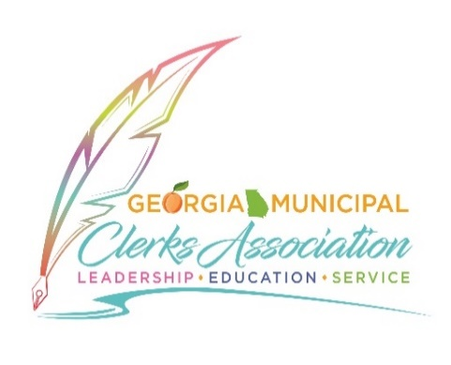 2023 GEORGIA MUNICIPAL CLERK OF THE YEAR AWARD
During the June Convention in Savannah, the Clerk of the Year Award will be presented to an outstanding City Clerk at the Awards Luncheon. Your Clerk may be eligible for this award, and you can show him/her your appreciation by your nomination. He or she must be an active member of the Georgia Municipal Clerks Association and have been active in GMCA activities. They must also be a certified municipal clerk or working towards their certification. Other criteria considered include job performance, experience, accomplishments, quality of work, length of service, professional development (leadership, education, and service), and invaluable support to the staff and community.
To nominate someone for this award, complete the following application and include a narrative of 50 words or less on the Clerk's activities that would merit consideration for the award. Feel free to attach a bio or resume of the clerk.
Please send your nomination by May 15 to richard.mccoy@cityofwestpointga.com.
NOMINEE NAME: |  |  |  |  |  |  |  |  |  |  |  |  | CITY:
EMAIL: |  |  |  |  |  |  |  |  |  |  |  |  | PHONE:
NOMINATED BY: |  |  |  |  |  |  |  |  |  |  |  |  | TITLE:
EMAIL: |  |  |  |  |  |  |  |  |  |  |  |  | PHONE:
Please provide information on why the nominee should be considered for this award:
Number of years served as a clerk: |  |  |  |  |  |  |  |  | GMCA Membership: |  |  | Yes |  |  |  |  |  | No
Number of years served in government:
List certifications achieved, if any:
List of leadership positions held, if any:
List of any local, State or other awards:
Additional narrative of why clerk’s activities would merit consideration for the award (50 words or less):

Please send your nomination by May 15 to richard.mccoy@cityofwestpointga.com.

